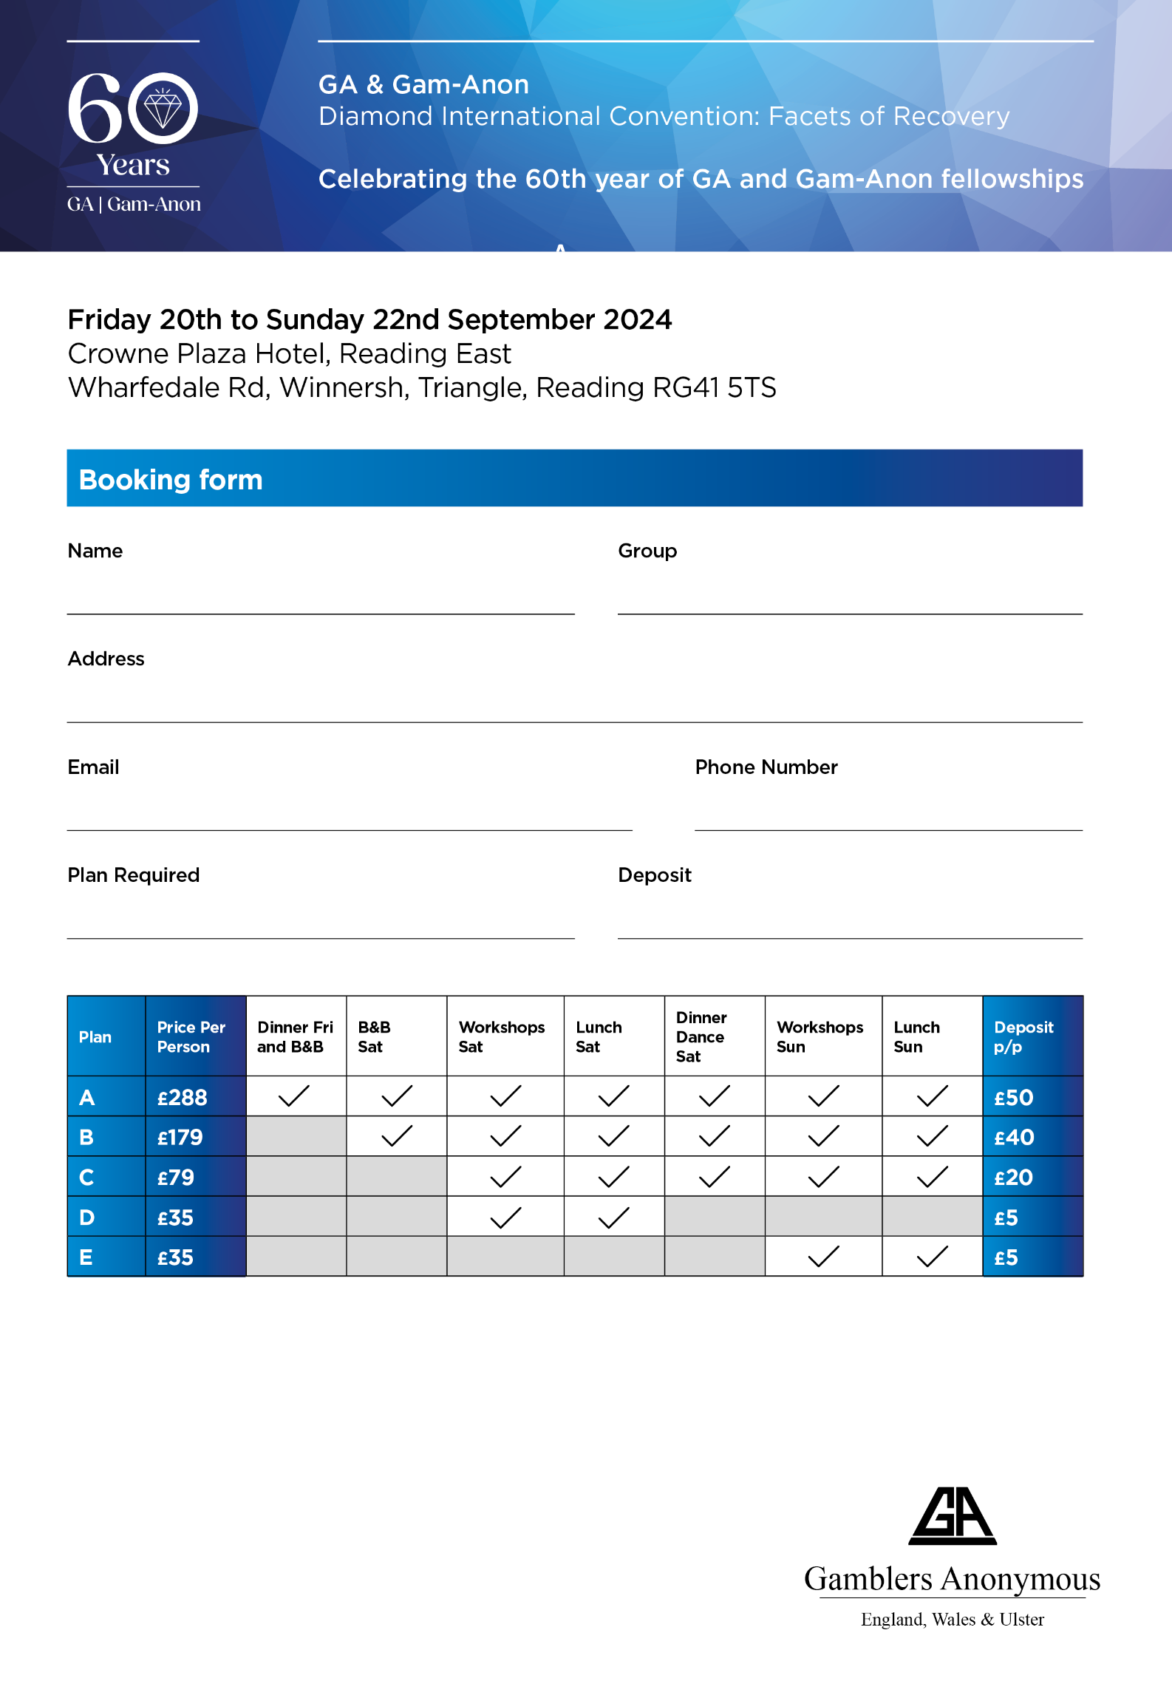

**GA & Gam-Anon**

**Diamond international Convention: Facets of Recovery**

**Celebrating the 60th year of GA and Gam-Anon fellowships**

**Friday 20th to Sunday 22nd September 2024**

**Crowne Plaza Hotel, Winnersh Triangle**

**Booking Form**

**Name: Group:**

**Address:**

**E-mail: Phone Number:**

**Plan Required: Deposit *(Non-Refundable)*:**



**Bookings must not be made directly with the Hotel. If this occurs, we will not be able to honour your Convention booking as we must ensure all convention costs are covered.**

Payments to Barclays Bank Business A/c Name: PTGA Sort Code: 20-63-25 Account No: 00453374

For International payments: SWIFTBIC BUKBGB22 IBAN GB85 BUKB 2063 2500 4533 74

For bookings please contact: [readingconvention.2024@gmail.com](mailto:readingconvention.2024@gmail.com) **or** Tel: +44 7799 640769 (Bev N) / +44 7970 457336 (Satty M)

**Please use these contact details if you would like to chair a workshop or be of service during the convention.**

People resident at the hotel will also have use of the Esprit Wellness & Spa including 19m indoor Pool, Fitness Gym, Sauna & Steam Room.

